HTX Technical Test Design Specification
Author: Zackery Wong Yi Zhu
Date: 6 June 2026
Contents
HTX Technical Test Design Specification 1
1. Process Flow 2
2. System Components 2
Traveller 2
Baggage Security Counters 2
No Baggage Security Counters 2
Auto Passport Counters 3
Manual Passport Counters 3
Referral Counter 3
3. Input Parameters 3
4. Simulation Outputs 4
Setup 1: 4
Setup 2: 6
Queue Length Comparison 7
Average time in Checkpoint Analysis 8
Bottleneck Analysis 8
Throughput analysis 9
5. Assumption 9

Process Flow
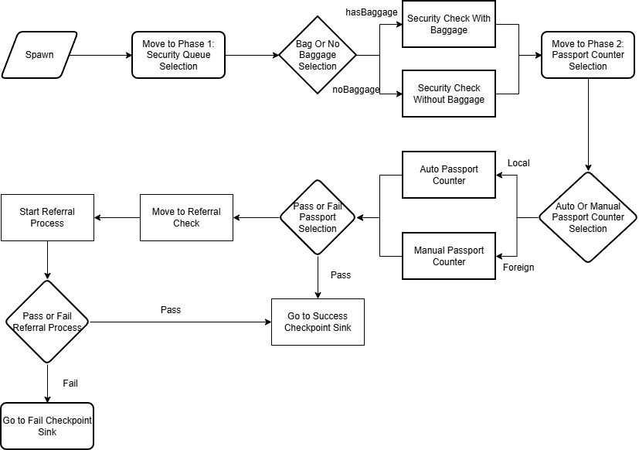

System Components

Traveller
Parameters:
isLocal – bool (True/False)
hasBaggage – bool (True/False)
riskProfile – int (0,1,2,3) 0 = Low Risk, 1=Medium Risk, 2 = High Risk, 3 = Extreme Risk
docReady int (0,1,2) 0 = Ready, 1 = Partial ready, 2 = Not Ready

Baggage Security Counters
Number of counters – 8
Number of officers – 8
Number of queues – 1 (Setup 1), 8 (Setup 2)
Queue Time: triangular(20, 25, 30) * (1.0 + (((Traveller)ped).riskProfile * 0.1))

No Baggage Security Counters
Number of counters – 3
Number of officers – 1
Number of queues – 3
Queue Time: triangular(5, 10, 15) * (1.0 + (((Traveller)ped).riskProfile * 0.1))

Auto Passport Counters
Number of counters – 11
Number of officers – 0
Number of queues – 3
Queue Time: triangular(5, 10, 15) * (1.0 + (((Traveller)ped).riskProfile * 0.1)) * (1.0 + (((Traveller)ped).docReadiness * 0.1))

Manual Passport Counters
Number of counters – 4
Number of officers – 4
Number of queues – 4
Queue Time: triangular(10, 20, 30) * (1.0 + (((Traveller)ped).riskProfile * 0.1)) * (1.0 + (((Traveller)ped).docReadiness * 0.1))

Referral Counter
Number of counters – 1
Number of officers – 1
Number of queues – 1
Queue Time: triangular(60, 120, 180) * (1.0 + (((Traveller)ped).riskProfile * 1))

Input Parameters
Arrival Spawn Rate: 1500
isLocal Chance: 50%
hasBaggage Chance: 70%
Risk Profile Distribution:
Risk Profile | Weight
0 | 0.84
1 | 0.10
2 | 0.05
3 | 0.01

Document Readiness Distribution
Document Readiness Profile | Weight
0 | 0.80
1 | 0.15
2 | 0.05

Referral Rate: 1%
Referral Pass Chance: 50%
Simulation Runtime : 60 minutes

Simulation Outputs

Setup 1:
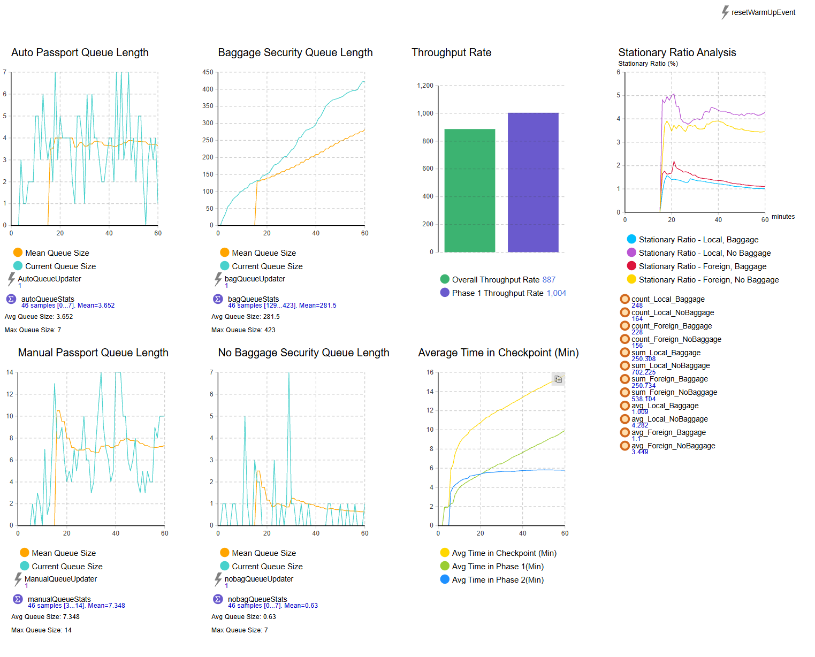
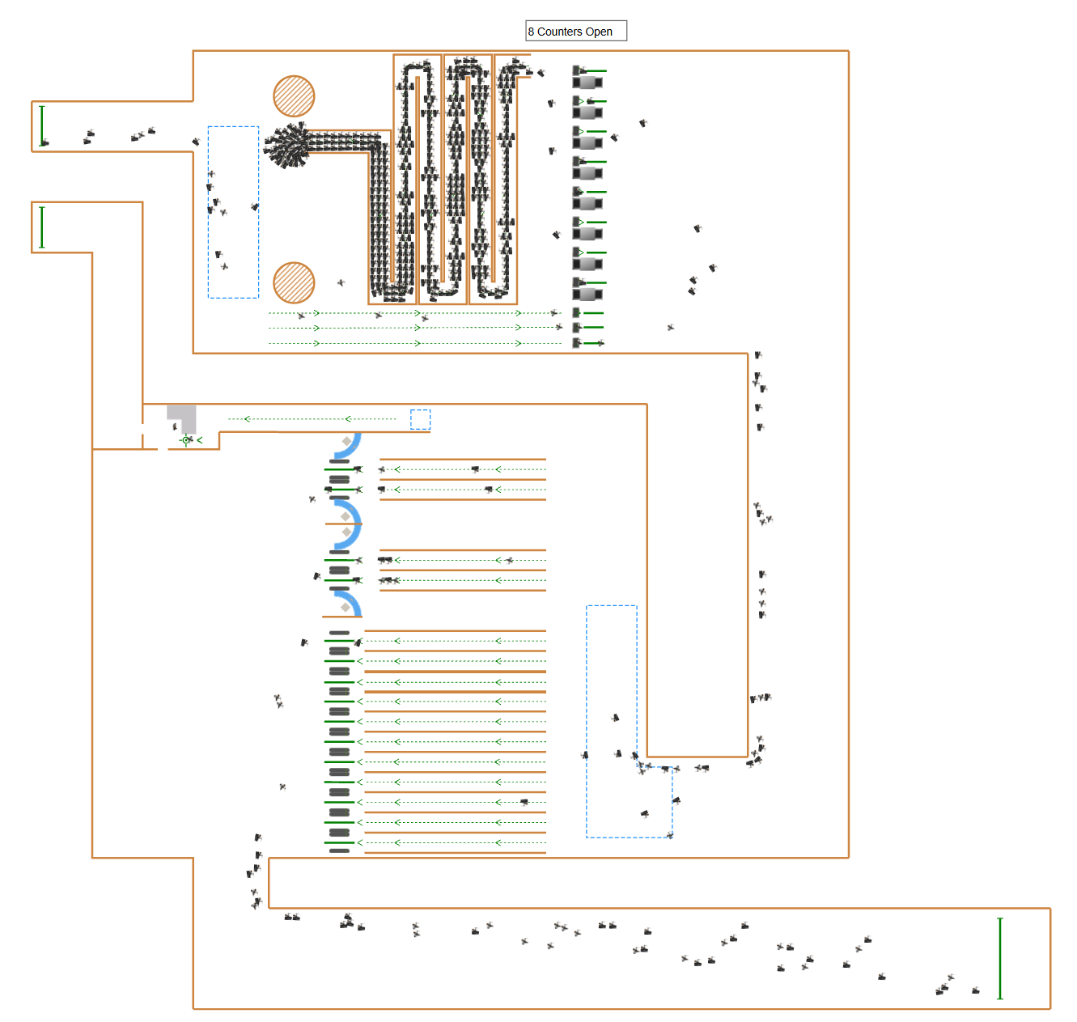
In Setup 1: We identify a bottleneck through the simulation. At Security check Auto Queue, we notice that travellers are stuck in queue for a longer duration.

Setup 2:
We swap the 1 serpentine queue into 8 straight line for each counter in the attempt to address the bottleneck.
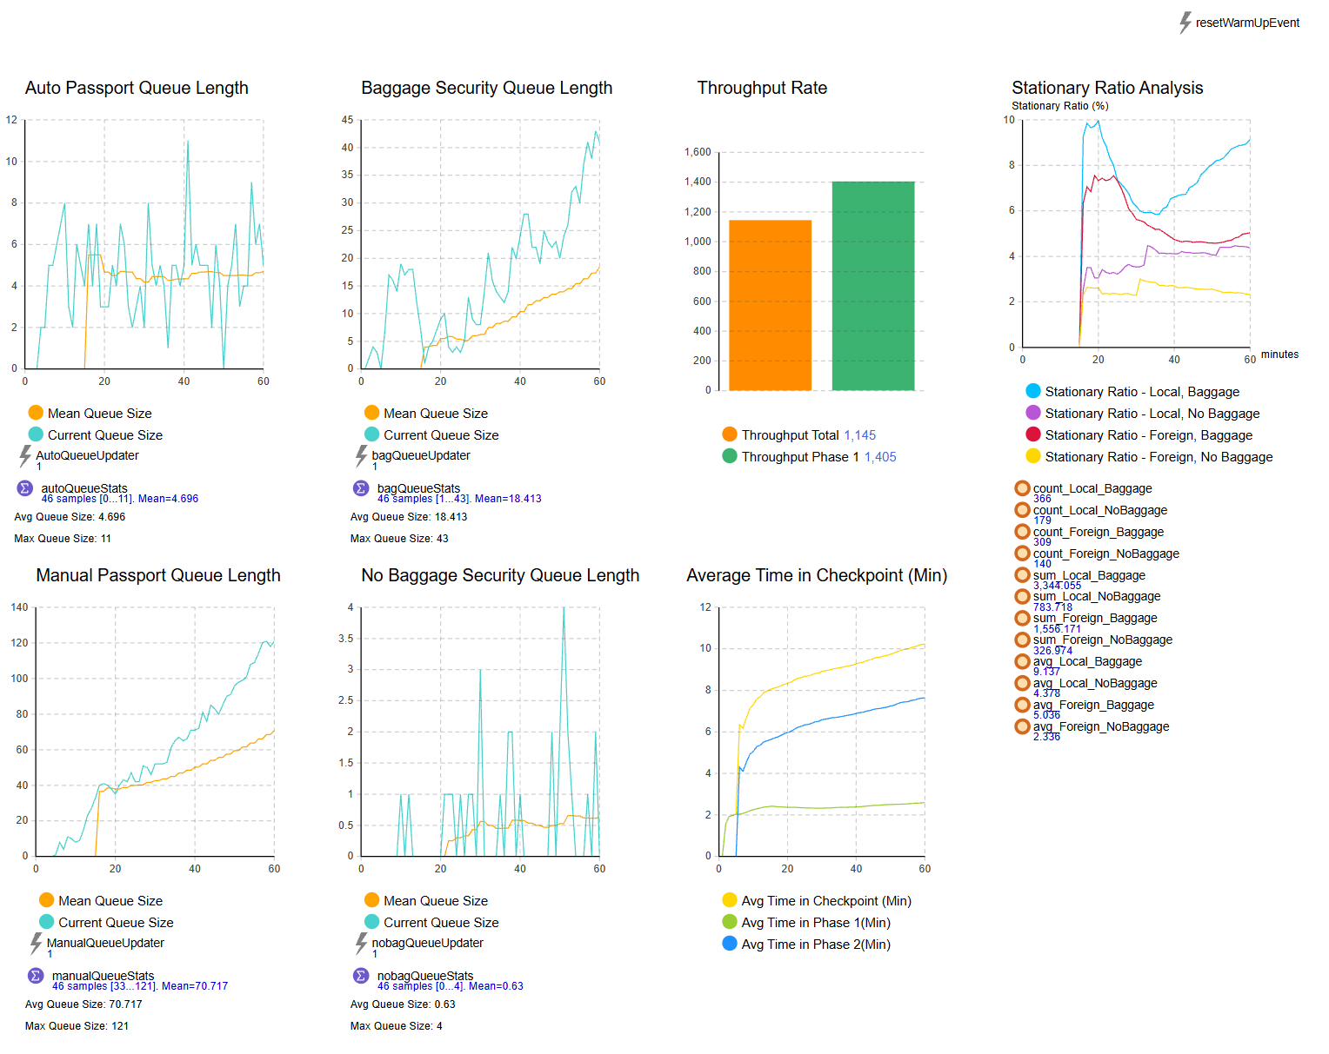
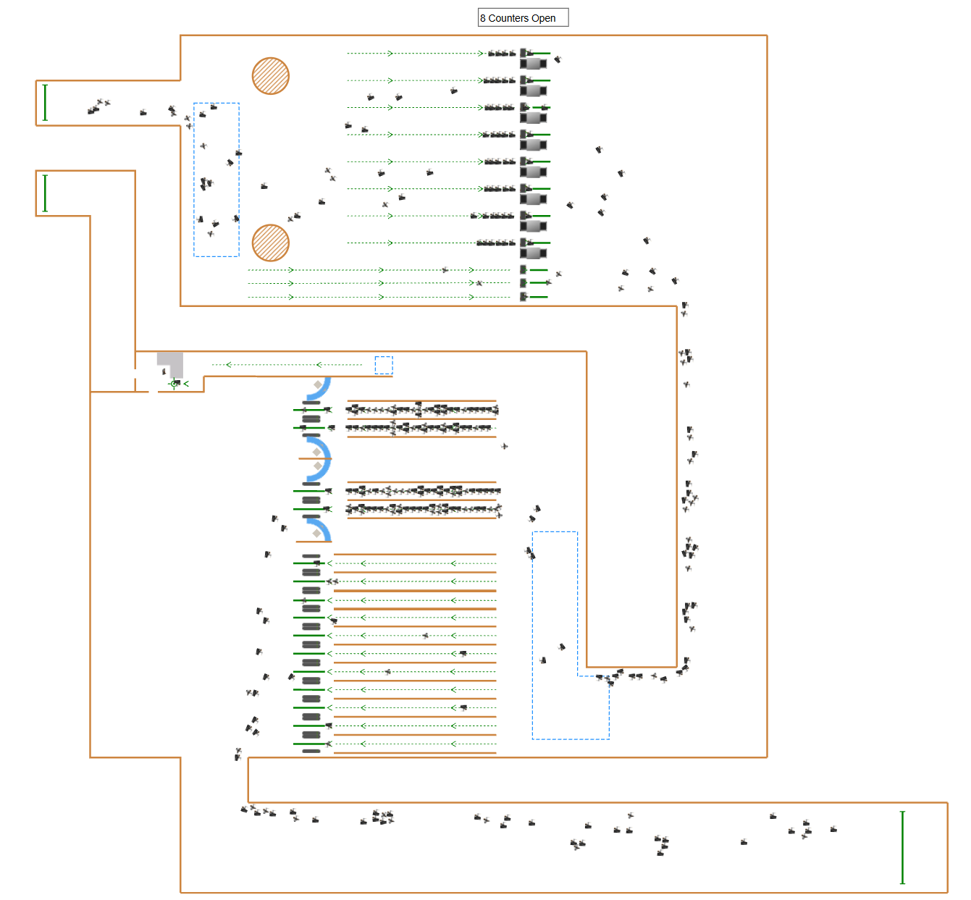

Queue Length Comparison
We immediately see significant improvements for pedestrian flow. Dropping the average queue size from 281 to 18
Setup 1 | Setup 2
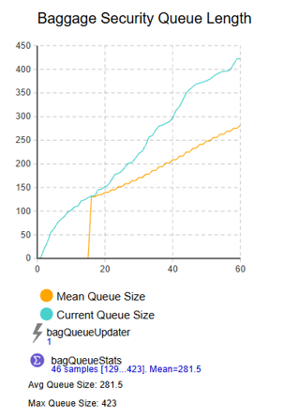 | 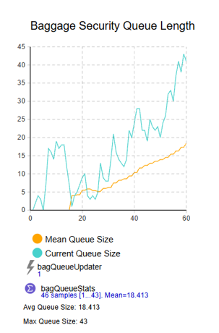

Average time in Checkpoint Analysis
We also notice a considerable drop in the average time spent in phase 1. A more uniform average time spent rather than an increasing one due to the previous bottleneck. Average overall Time spent also improves with it peaking at 10min rather than 16min. However, we also observe that Phase 2’s performance dropped due to more travellers making it through phase 1.
Setup 1 | Setup 2
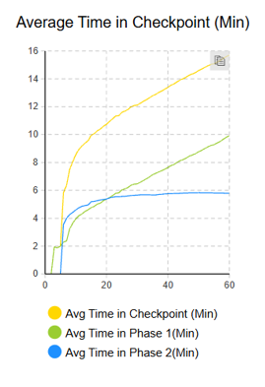 | 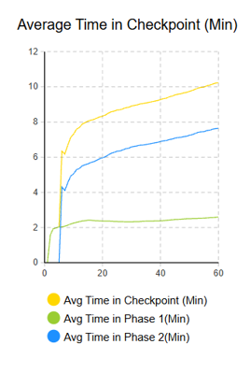

Bottleneck Analysis
We now notice that the bottleneck has shifted over to the Manual Passport Counters from the graphical visualization of our simulation and the average time spent comparison.
Setup 1 – Baggage Counters | Setup 2 – Baggage Counters
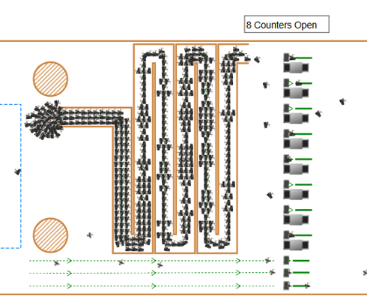 | 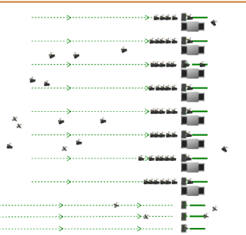
Setup 1 – Manual Passport Counters | Setup 2 – Manual Passport Counters
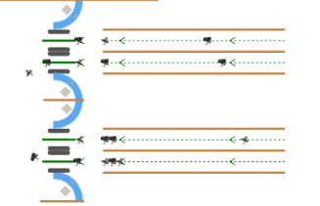 | 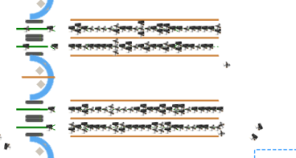

Throughput analysis
Our throughput rate also improves. Increasing phase 1 Throughput by 401 and the overall throughput by 258. Overall Setup 2 performs better than setup 1 by around 30%. This can be further improved by addressing the Manual passport counters bottleneck.
Setup 1 | Setup 2
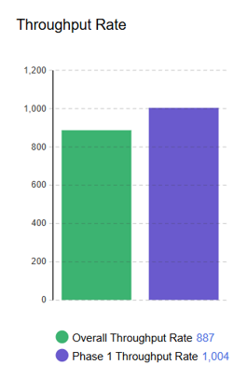 | 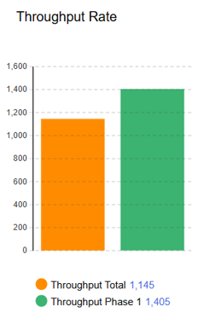

Assumption
- All travellers must complete a Security Check in Phase 1
- All travellers must complete a Passport Check in Phase 2
- All travellers will spend Uniform 0-15 Seconds deciding which counter they want to go to before Phase 1 and Phase 2 (Decision making)
- If a traveller fails the passport check, they will be sent to a referral counter to go through another check to decide if they are allowed to enter the country.
- All checks use a base triangular distribution and will have a multiplier added to this time depending on their risk profile and or Document readiness
- When a traveller is going through referral, they have a 50% chance of failing and being sent back.
- All checks are done 1 traveller at a time. There is no group entry here.
- 1 Hour simulation is used on both setups.

